SIMATS ENGINEERING
ASSESSMENT TOOL I — Uncertainty Visualization Lab
Course: Data Handling and Visualization | Code: DSA06 | CO: CO5
Duration: 180 min | Total Marks: 100 | Reg No :  Name:

COURSE OUTCOME COVERED
CO3: Analyze time-series data, trends, associations, and uncertainty through appropriate visualization methods. (BL4)
Activity Tool : Uncertainty Visualization Lab
Weightage: 20%
Code of Conduct:
I __________Neeleash H (192524093)____________ (Name / Reg No) certify that this submission is my original work and that I have adhered to the guidelines specified for this assessment. I understand that any violation of academic integrity rules will result in disciplinary action.
Signature of the student:
Criteria | Understanding of Uncertainty  25% | Visualization of Uncertainty  25% | Application of Visualization Principles  20% | Organization 20% | Accuracy 10% | Clarity 5% | Total
Q1
Q2
Q3
Q4
Q5

Uncertainty Visualization Lab – Assessment Tool
R Programming Practical Questions with Datasets
Instructions: Answer all five questions. Use R programming to construct the required visualization, interpret uncertainty, and identify potential visualization pitfalls. Use the given data exactly unless a transformation is explicitly requested.
Q1. Bootstrapping and Confidence Intervals – Point Estimate
A quality-control team records the following delivery times (in minutes) for 12 randomly selected orders. Using R, calculate the sample mean and obtain a 95% bootstrap confidence interval for the mean using at least 5,000 bootstrap resamples. Visualize the bootstrap distribution and mark the observed mean.
Data: 31, 35, 28, 42, 37, 33, 45, 29, 39, 34, 41, 36
Expected R tasks: resampling, point estimate, confidence interval, histogram/density plot, interpretation. Q2. Uncertainty in Trend Estimation
The following data represent monthly advertising expenditure and sales. Fit a linear regression model in R to estimate the sales trend. Plot the observations with the fitted regression line and a 95% confidence band. Explain how the uncertainty changes across the range of advertising expenditure.
Data: Advertising = 10, 12, 15, 18, 20, 23, 25, 28, 30, 33, 36, 40;
Sales = 48, 51, 53, 57, 60, 61, 66, 69, 72, 75, 79, 84
Expected R tasks: lm(), prediction interval/confidence interval, ggplot2 visualization, trend interpretation. Q3. Overplotting, Jittering and Transparency
A survey records the number of hours studied and examination scores for 30 students. Several students have identical values. Create a scatterplot in R first without modification, then redesign it using partial transparency and jittering. Compare the two plots and explain how overplotting affects interpretation.
Data: Hours = 2,3,3,4,4,4,5,5,5,5,6,6,6,6,6,7,7,7,7,7,8,8,8,8,8,9,9,9,10,10;
Scores = 45,52,52,58,60,60,64,66,66,66,70,72,72,72,72,76,78,78,80,80,84,84,85,85,85,88,90,90,94,94 Expected R tasks: geom_point(), alpha, position_jitter(), comparison of overplotting.
Q4. 2D Histogram and Density Estimation
A researcher measures height and weight for 20 participants. Construct a 2D histogram and a 2D density visualization in R. Use the plots to identify regions with high observation density. State which visualization communicates concentration more clearly and justify your choice.
Data: Height = 150,152,155,158,160,161,163,165,166,168,170,171,173,175,176,178,180,182,184,186;
Weight = 48,50,53,55,57,59,60,62,64,65,68,69,71,73,74,77,80,82,85,88
Expected R tasks: 2D binning, density estimation, contour/density layers, interpretation of concentration. Q5. Color Scales, Accessibility and Misleading Visualization
The following category-wise satisfaction scores must be visualized in R. Create two plots: (1) a plot using a nonmonotonic/diverging color scheme that could mislead interpretation, and (2) a redesigned plot using an ordered, color-vision-deficiency-friendly sequential scale. Explain why the second design is more effective and identify the visualization pitfall in the first design.
Data: Category = A,B,C,D,E,F,G;
Satisfaction = 42,48,55,61,67,74,82
Expected R tasks: color mapping, scale selection, accessibility-aware redesign, critique of misleading color use.
Suggested R packages: ggplot2, dplyr, boot (or base R).
Assessment focus: Correct R code, appropriate uncertainty visualization, interpretation, and identification of misleading design choices.

Answers
Q1. Bootstrapping and Confidence Intervals – Point Estimate
R code and output:
library(ggplot2)
delivery_time <- c(31, 35, 28, 42, 37, 33,
45, 29, 39, 34, 41, 36)
observed_mean <- mean(delivery_time)
set.seed(123)
B <- 10000
bootstrap_means <- replicate(
B,
mean(sample(delivery_time,
size = length(delivery_time),
replace = TRUE))
)
bootstrap_ci <- quantile(
bootstrap_means,
probs = c(0.025, 0.975)
)
cat("Sample Mean =", observed_mean, "\n")
cat("95% Bootstrap Confidence Interval:\n")
print(bootstrap_ci)
boot_data <- data.frame(mean = bootstrap_means)
ggplot(boot_data, aes(x = mean)) +
geom_histogram(
bins = 30,
fill = "skyblue",
color = "black"
) +
geom_vline(
xintercept = observed_mean,
color = "red",
linewidth = 1.2
) +
geom_vline(
xintercept = bootstrap_ci,
linetype = "dashed",
color = "darkgreen",
linewidth = 1
) +
labs(
title = "Bootstrap Distribution of Delivery-Time Mean",
x = "Bootstrap Sample Mean",
y = "Frequency"
) +
theme_minimal()

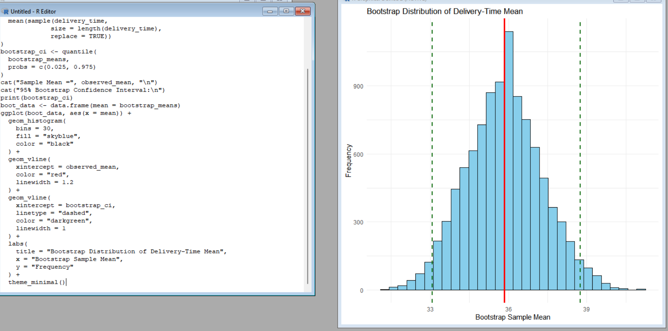

Expected result
The observed sample mean is:
Mean ≈ 35.83 minutes
The exact bootstrap confidence interval can vary slightly because bootstrap resampling is random. With set.seed(123) and 10,000 resamples, it should be around:
95% CI ≈ 33.08 to 38.75 minutes
Interpretation
The average delivery time in the observed sample is approximately 35.83 minutes. The 95% bootstrap confidence interval indicates that the population mean delivery time is reasonably estimated to lie between approximately 33 and 39 minutes.
The histogram represents the distribution of bootstrap sample means. The red vertical line represents the observed sample mean, while the dashed lines represent the confidence interval.

Q2. Uncertainty in Trend Estimation:
library(ggplot2)
advertising <- c(10, 12, 15, 18, 20, 23,
25, 28, 30, 33, 36, 40)

sales <- c(48, 51, 53, 57, 60, 61,
66, 69, 72, 75, 79, 84)
data <- data.frame(
Advertising = advertising,
Sales = sales
)
model <- lm(Sales ~ Advertising, data = data)
summary(model)
ggplot(data, aes(x = Advertising, y = Sales)) +
geom_point(size = 3) +
geom_smooth(
method = "lm",
formula = y ~ x,
level = 0.95,
se = TRUE
) +
labs(
title = "Advertising Expenditure vs Sales",
x = "Advertising Expenditure",
y = "Sales"
) +
theme_minimal()
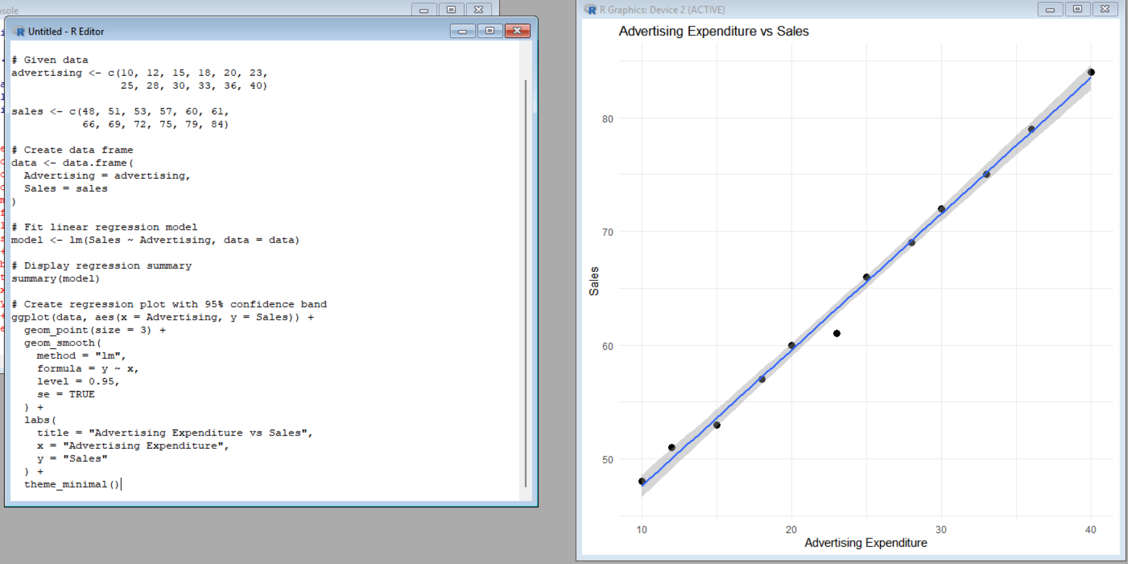

Interpretation
The scatterplot shows a positive relationship between advertising expenditure and sales. As advertising expenditure increases, sales also tend to increase.
The regression line represents the estimated average trend.
The shaded region around the regression line is the 95% confidence band. It represents uncertainty about the estimated mean sales at different advertising expenditure levels.
The confidence band is generally narrower near the center of the observed advertising range and becomes wider toward the boundaries because there is less information for estimating the trend at the extremes.
Conclusion
There is a clear positive sales trend with increasing advertising expenditure. However, predictions near the extreme values of advertising expenditure have greater uncertainty than estimates near the center of the data.

Q3. Overplotting, Jittering and Transparency:
library(ggplot2)
hours <- c(2,3,3,4,4,4,5,5,5,5,
6,6,6,6,6,7,7,7,7,7,
8,8,8,8,8,9,9,9,10,10)

scores <- c(45,52,52,58,60,60,64,66,66,66,
70,72,72,72,72,76,78,78,80,80,
84,84,85,85,85,88,90,90,94,94)
data <- data.frame(
Hours = hours,
Scores = scores
)
ggplot(data, aes(x = Hours, y = Scores)) +
geom_point(size = 3) +
labs(
title = "Original Scatterplot",
x = "Hours Studied",
y = "Examination Score"
) +
theme_minimal()
ggplot(data, aes(x = Hours, y = Scores)) +
geom_jitter(
width = 0.15,
height = 0.8,
alpha = 0.5,
size = 3
) +
labs(
title = "Scatterplot with Jittering and Transparency",
x = "Hours Studied",
y = "Examination Score"
) +
theme_minimal()

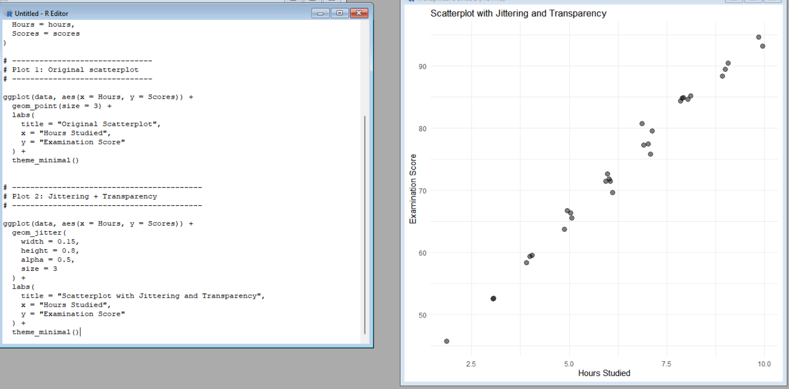

Comparison
In the first plot, several students have identical values. Therefore, some points are placed directly on top of one another. This is called overplotting.
Overplotting can hide the number of observations at a particular location and make the data distribution difficult to interpret.
The second plot uses:
- Jittering to slightly move overlapping points.
- Transparency (alpha) to make overlapping observations more visible.
Interpretation
The redesigned plot provides a clearer view of the distribution of students. It makes repeated observations easier to identify and reduces the misleading appearance caused by overlapping points.
There is also a general positive relationship between hours studied and examination score.
Conclusion
Jittering and transparency improve the readability of the visualization when multiple observations have identical or very similar values.

Q4. 2D Histogram and Density Estimation:

library(ggplot2)
height <- c(150,152,155,158,160,161,163,165,166,168,
170,171,173,175,176,178,180,182,184,186)

weight <- c(48,50,53,55,57,59,60,62,64,65,
68,69,71,73,74,77,80,82,85,88)
data <- data.frame(
Height = height,
Weight = weight
)
ggplot(data, aes(x = Height, y = Weight)) +
geom_bin2d(bins = 6) +
labs(
title = "2D Histogram of Height and Weight",
x = "Height (cm)",
y = "Weight (kg)"
) +
theme_minimal()
ggplot(data, aes(x = Height, y = Weight)) +
geom_density_2d() +
geom_point(alpha = 0.5) +
labs(
title = "2D Density Plot of Height and Weight",
x = "Height (cm)",
y = "Weight (kg)"
) +
theme_minimal()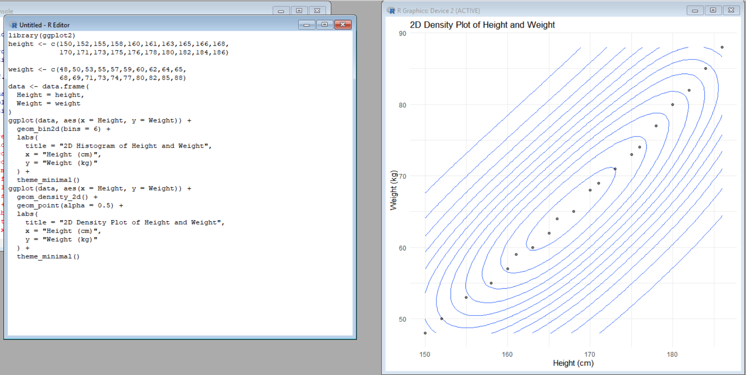

Interpretation
The data shows a positive relationship between height and weight. As height increases, weight generally increases as well.
The 2D histogram divides the plotting area into rectangular bins. Areas containing more observations represent higher concentration.
The density plot estimates the underlying concentration of observations using smooth density contours.
Which is clearer?
The 2D density visualization generally communicates concentration more clearly because it provides a smooth representation of where observations are concentrated instead of depending only on rectangular bins.
The 2D histogram is useful when the actual count within regions is important, while density contours are useful for understanding the overall shape and concentration of the distribution.

Q5. Color Scales, Accessibility and Misleading Visualization:

library(ggplot2)
category <- c("A", "B", "C", "D", "E", "F", "G")
satisfaction <- c(42, 48, 55, 61, 67, 74, 82)
data <- data.frame(
Category = category,
Satisfaction = satisfaction
)-
ggplot(data, aes(x = Category, y = Satisfaction, fill = Satisfaction)) +
geom_col() +
scale_fill_gradient2(
low = "blue",
mid = "white",
high = "red",
midpoint = 62
) +
labs(
title = "Misleading Diverging Color Scale",
x = "Category",
y = "Satisfaction Score",
fill = "Satisfaction"
) +
theme_minimal()
ggplot(data, aes(x = Category, y = Satisfaction, fill = Satisfaction)) +
geom_col() +
scale_fill_viridis_c(
option = "viridis",
direction = 1
) +
labs(
title = "Accessible Sequential Color Scale",
x = "Category",
y = "Satisfaction Score",
fill = "Satisfaction"
) +
theme_minimal()

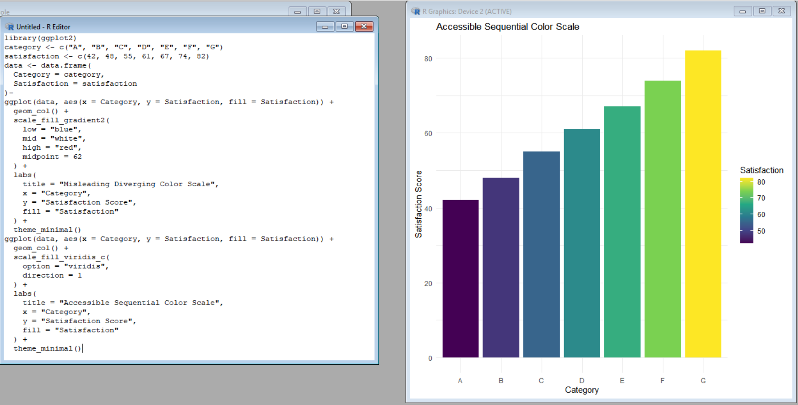

Interpretation:
The second plot uses the Viridis sequential color scale.
A sequential scale is appropriate because satisfaction scores have an ordered progression from lower to higher values.
The Viridis scale is also designed to be more accessible to people with different forms of color-vision deficiency.
Conclusion
The second visualization is more effective because:
- The colors progress in an ordered manner.
- Higher and lower values are easier to distinguish.
- It does not introduce an artificial midpoint.
- It is more accessible to viewers with color-vision deficiencies.
- The color mapping better represents the numerical nature of satisfaction scores.
The main pitfall in the first visualization is the inappropriate use of a diverging/nonmonotonic color scale for an ordered variable.

